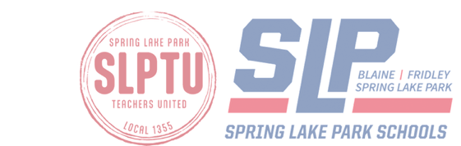Teacher of the Year Nomination Form 2026-2027 Spring Lake Park Schools
- Early Ed/Elementary Teacher of the Year (ECFE - 5th grade)
- Secondary Teacher of the Year (6th - 12th grade)
CRITERIA for nomination:
- Possess a teaching license issued by the state of Minnesota (and a baccalaureate degree or higher).
- Minimum three years of teaching experience (including current year) and intend to teach for two more years.
- Belong to Spring Lake Park Teachers United (SLPTU).
You can choose one or more teachers who represent District 16. Counselors and special education case managers are also eligible for nomination at both levels. After the deadline, all application materials will be given to the SLPTU President, then the Selection Committee will meet and select the elementary and secondary winners. The two winners who best represent District 16 will be announced and awarded during an SLPTU Spring Social event. Thank you for taking the time to nominate an educator!
NOMINATOR: (Your name)
______Student _____ Staff Member _____Parent ____ Community Member ____Anonymous
Your School/Building (if applicable):
Briefly, explain why you chose to nominate this teacher/counselor/case manager: (3 – 4 sentences) ____________________________________________________________________________________________________________________________________________________________________________________
NOMINEE:
School/Building: Department: ____________________
Grade Level: Subject Taught or Role:
Email or return completed form by FEBRUARY 17TH, 2026 to the SLPHS main office with attention to:
Maria Ahrndt [SLPHS) or attach the form and explanation to Maria Ahrndt’s email: mahrnd@district16.org Please share this information with your students.

